**PIZZA SALES SQL QUERIES**

**KPI’s**

--1. Total Revenue:

Select sum (total_price) As Total_Revenue

from pizza;

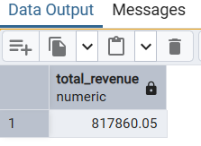

--2. Average Order Value

Select (sum (total_price) / count (Distinct order_id)) As Avg_order_value

from pizza;

--3. Total Pizzas Sold

Select sum (quantity) As Total_Pizza_Sold

from pizza;

--4. Total Orders

Select count (Distinct order_id) As Total_Orders

from pizza;

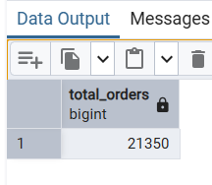

--5. Average Pizzas Per Order

Select Cast(Cast(Sum(quantity) As DECIMAL(10,2)) /

Cast (Count(Distinct order_id) As DECIMAL(10,2)) As DECIMAL(10,2))

AS Avg_Pizzas_per_order

From pizza;

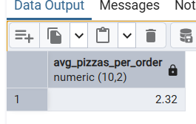

**Charts**

--6. Daily Trend for Total Orders

Select TO_CHAR(order_date, 'FMDay') as ORDER_DAY ,

count (Distinct order_id) as TOTAL_ORDERS

From pizza

Where order_date Is Not Null

group by TO_CHAR(order_date, 'FMDay');

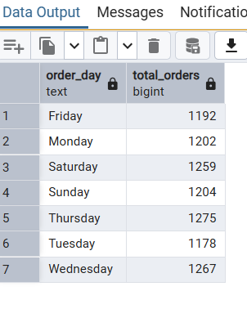

--7.Monthly Trend for Orders

Select TO_CHAR(order_date, 'Month') as ORDER_DAY ,

count (Distinct order_id) as TOTAL_ORDERS

From pizza

Where order_date Is Not Null

group by TO_CHAR(order_date, 'Month');

--8.% of Sales by Pizza Category

SELECT pizza_category, CAST(SUM(total_price) AS DECIMAL(10,2)) as total_revenue,

CAST(SUM(total_price) * 100 / (SELECT SUM(total_price) from pizza)

AS DECIMAL(10,2)) AS PCT

FROM pizza

GROUP BY pizza_category;

--9.% of Sales by Pizza Size

SELECT pizza_size, CAST(SUM(total_price) AS DECIMAL(10,2)) as total_revenue,

CAST(SUM(total_price) * 100 / (SELECT SUM(total_price) from pizza)

AS DECIMAL(10,2)) AS PCT

FROM pizza

GROUP BY pizza_size;

--10.Top 5 Pizzas by Revenue

select pizza_name ,sum(total_price) as total_revenue

FROM Pizza

GROUP BY pizza_name

ORDER BY total_revenue DESC

limit 5;

--11.Bottom 5 Pizzas by Revenue

select pizza_name ,sum(total_price) as total_revenue

FROM Pizza

GROUP BY pizza_name

ORDER BY total_revenue ASC

limit 5;

--12.Top 5 Pizzas by Quantity

select pizza_name ,sum(quantity) as Total_Pizza_Sold

FROM Pizza

GROUP BY pizza_name

ORDER BY Total_Pizza_Sold DESC

limit 5;

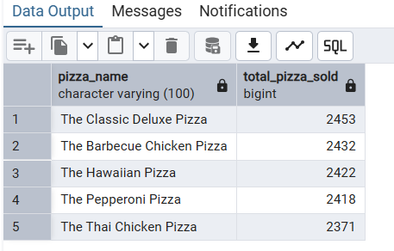

--13.Bottom 5 Pizzas by Quantity

select pizza_name ,sum(quantity) as Total_Pizza_Sold

FROM Pizza

GROUP BY pizza_name

ORDER BY Total_Pizza_Sold ASC

limit 5;

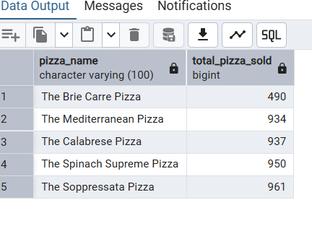

--14.Top 5 Pizzas by Total Orders

select pizza_name ,count (Distinct order_id) as Total_orders

FROM Pizza

GROUP BY pizza_name

ORDER BY Total_orders DESC

limit 5;

--15.Borrom 5 Pizzas by Total Orders

select pizza_name ,count (Distinct order_id) as Total_orders

FROM Pizza

GROUP BY pizza_name

ORDER BY Total_orders ASC

limit 5;

